Living with Scents, featuring over 40 international designers,
challenges the way we relate to the world through olfactory design.

The Museum of Craft and Design announces a new exhibition of sensory awareness.

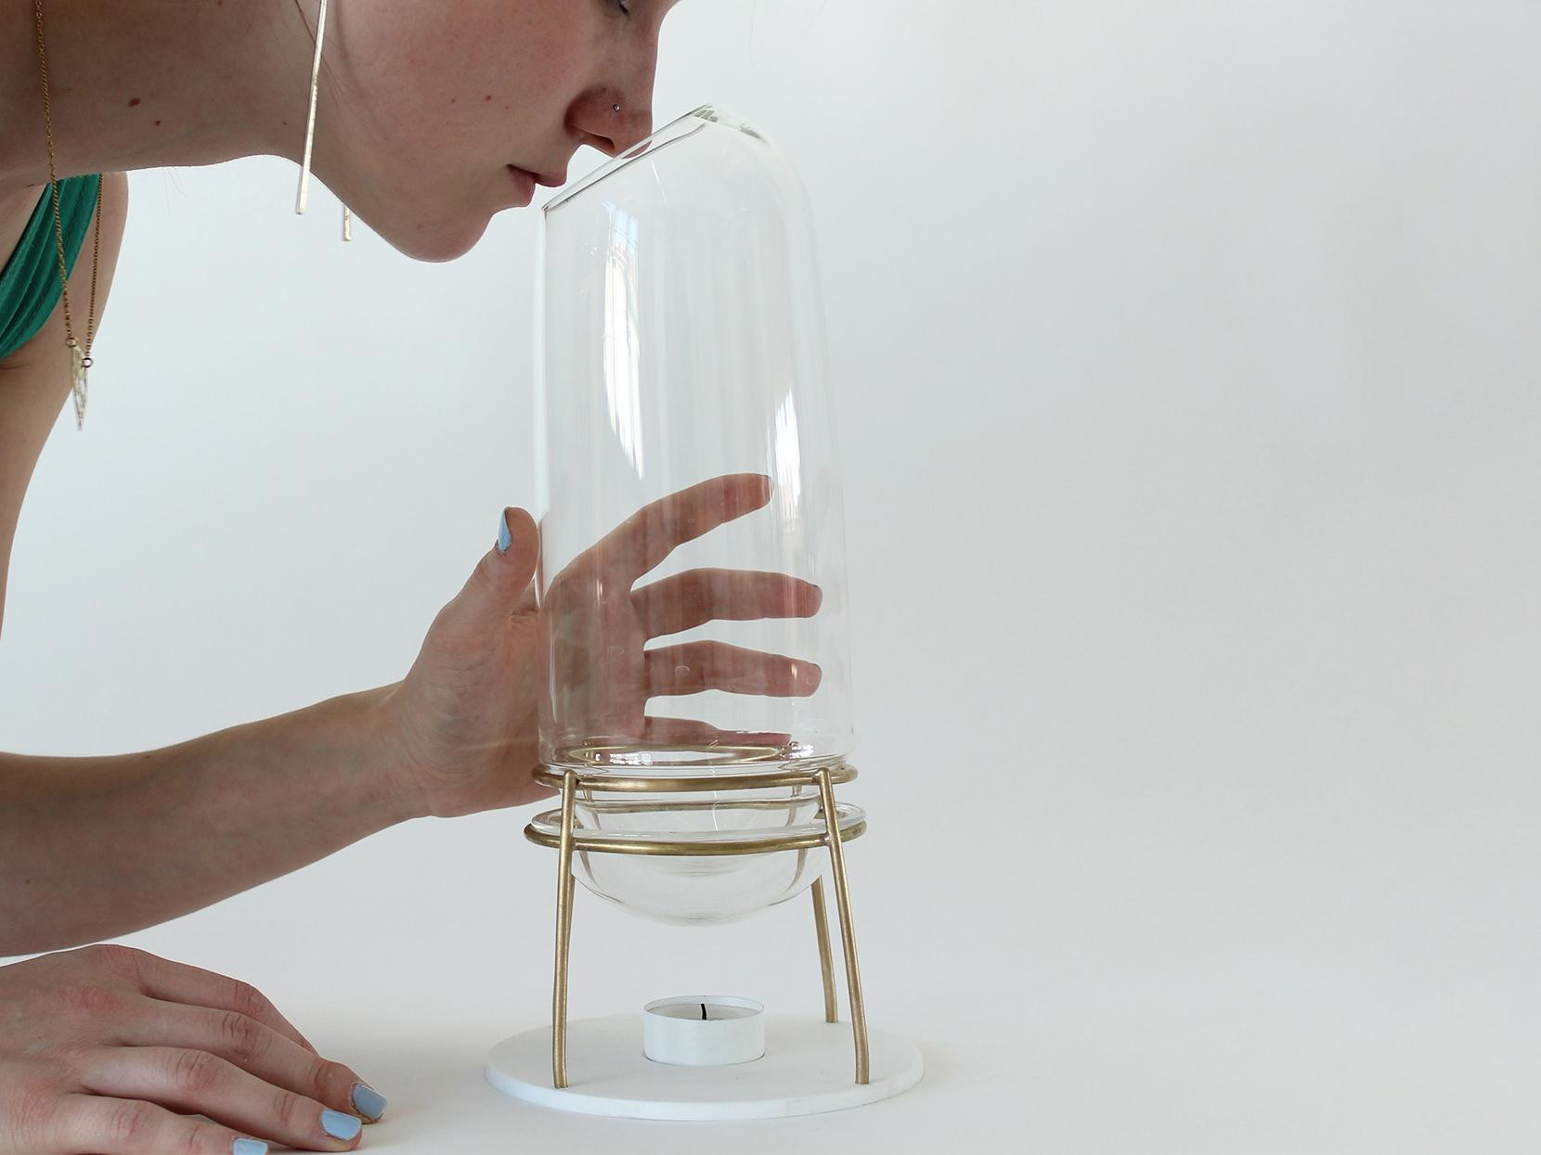

San Francisco, CA (October 27, 2021) The Museum of Craft and Design (MCD) is pleased to announce Living with Scents, on view February 11–June 5, 2022, featuring over 40 designers and artists from around the world whose work reflects and participates in the growing culturalization of all things olfactory. By considering the interactions of minds, bodies, and things, they mediate scents in innovative ways to raise a form of new sensory awareness. Guest curated by Elisabetta Pisu and Clara Muller, Living with Scents will focus on objects, not just scented products, but creative and artful interfaces to deliver scents with manifold design outcomes, from the hedonic to the functional. Structured into the five sections below, the exhibition will highlight major dimensions, themes, and approaches to olfactory design. Several works from each section will be activated, offering a unique museum-going experience based on both smell and sight.
Ways of Sensing. Olfactory Culture and Contemplation: This portion of the exhibition is dedicated to the aesthetic and cultural value of scents. The objects on display, such as L'Ascentium (2015) by French designer Charline Ronzon-Jaricot (pictured above), invite us to discover what it’s like to really smell, deliberately and thoughtfully. L'Ascentium is designed to decompose the fragrance notes of perfume. The headnotes are the first to rise to the top of the scent carafe; through the delicate warming process, the perfume scent changes and evolves. All the objects in this part of the exhibition prompt unusual gestures and behaviors, allowing for focused attention that highlights the remarkable capacities of our nose and olfactory brain.
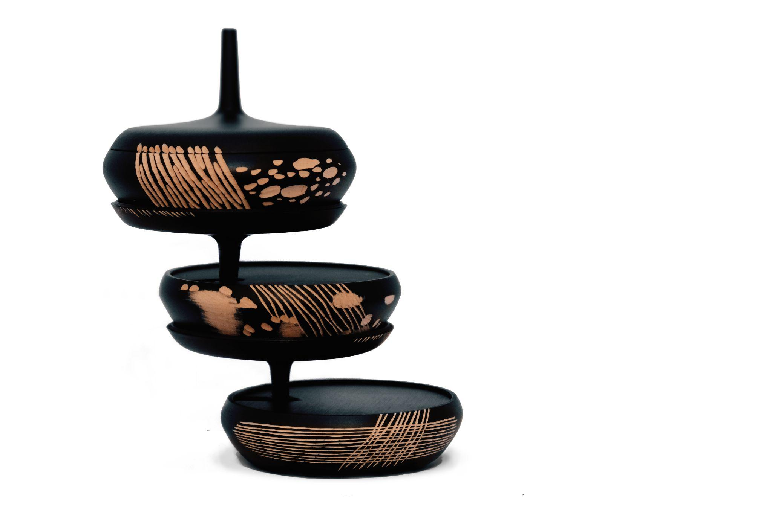

Nose Meets the Eye. The Power and Beauty of Nature: This section is an exploration of the aesthetics of uniquely designed scent diffusers in which there is more than meets the nose. Challenged by the need to create objects situated between beauty and efficiency, these designers work with a range of low-tech diffusing techniques and put an emphasis on materials, shapes, textures, and motions inspired by natural resources, forms, and phenomena. Designed by Monica Förster Design Studio and hand-carved by Zanat, Scentainer (2019) is a captivating wooden container designed to hold left-over wood chips which retain scents while beautifully stacking on top of each other to form a tree-like sculptural installation. The result becomes not only a functional diffuser but a hand-crafted work of art.
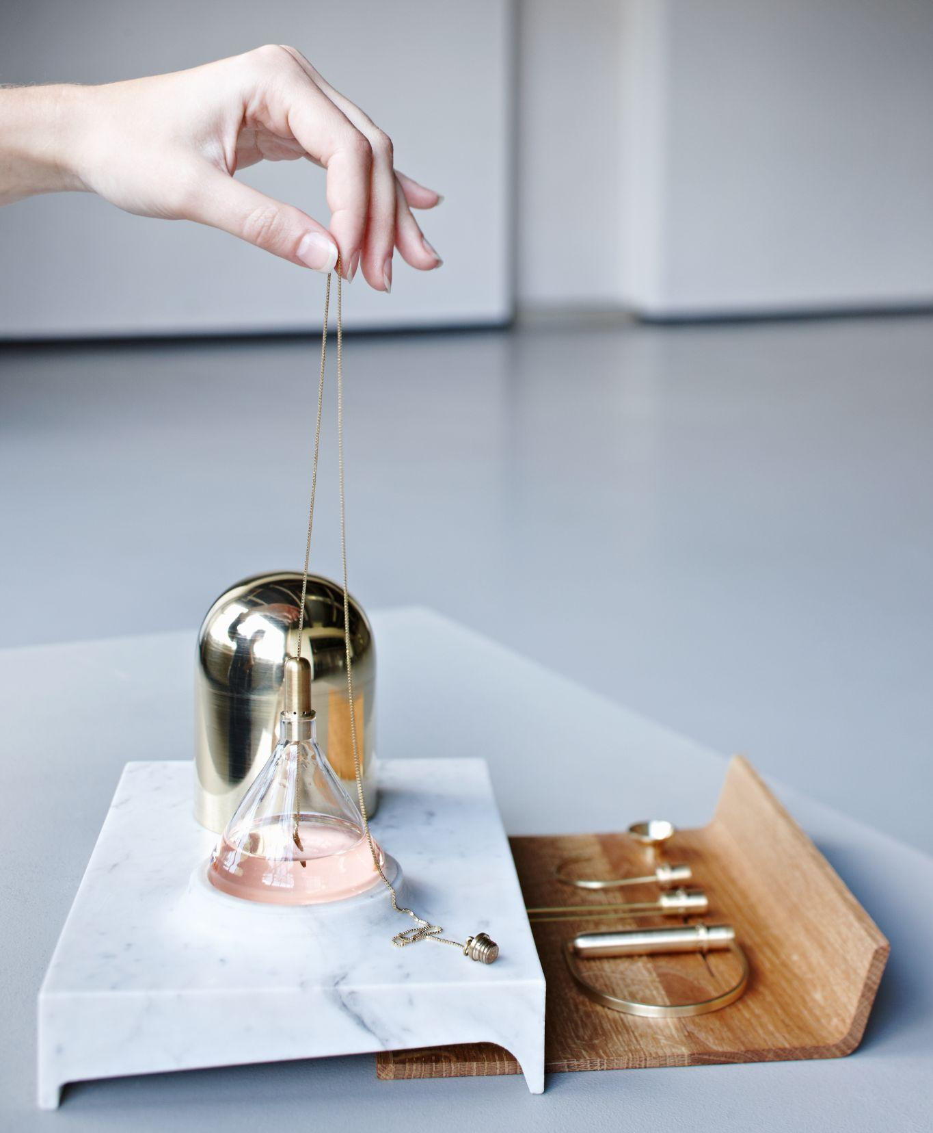
The Scent of Care. Health and Wellbeing: Throughout history, scents have been used to prevent and treat issues surrounding our physiological and psychological health, but the scents typically need interfaces in order to be properly used. The designers in this section have created objects that allow scents and fragrances to interact with and act on the body in beneficial ways. Jody Kocken’s Perfume Tools (2011) provide an elegant solution for those who have an allergic reaction to perfume. Kocken designed a series of elegant industrial jewelry pieces that attach to the opening of a perfume bottle absorbing the scent. When worn, they work as fragrance diffusers as the precious metal warms up and the scent is released. Any skin contact with the perfumed liquid is thus avoided.

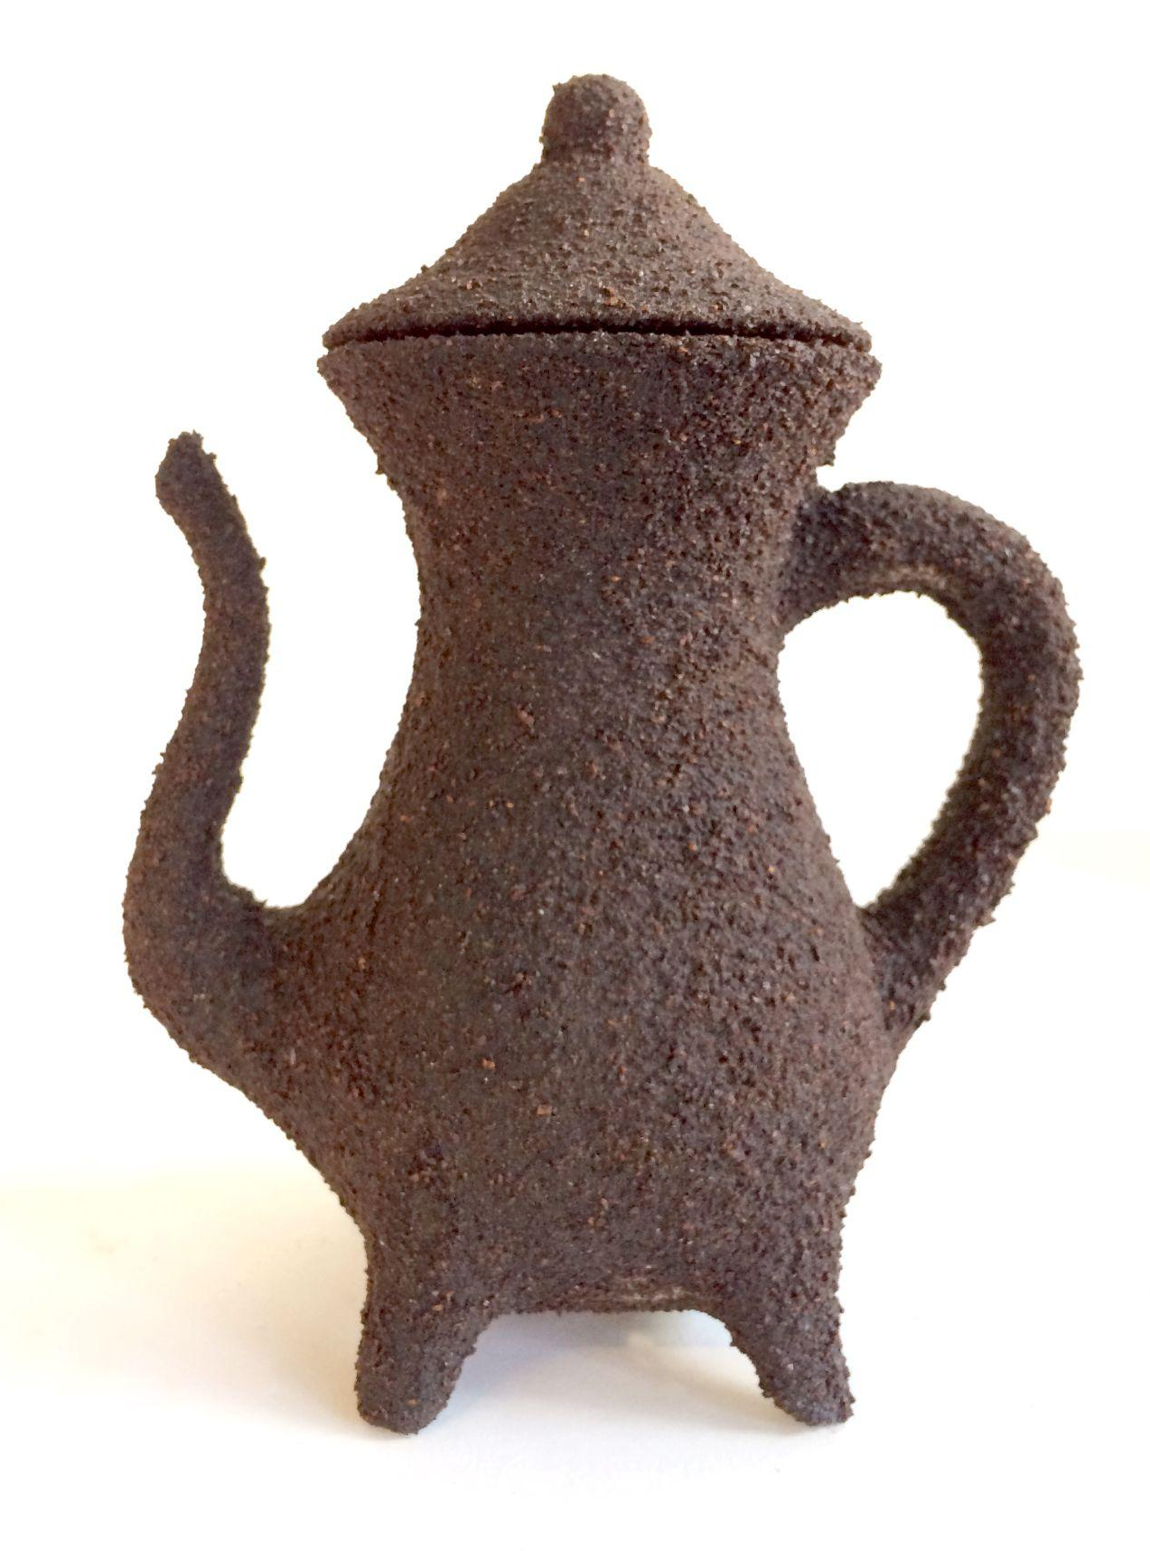
A Scented Art of Living. A New Sense of Presence and Pleasure: This section looks at innovative designs that introduce smells in our day-to-day environment. Some designers have created practical and decorative objects designed to perfume the spaces we live in, moving away from the traditional room spray, incense holder, or scented candle. Others challenge the way we perceive and interact with mundane objects by giving them an unexpected redolent dimension such as Virginia San Fratello and Ronald Rael’s Coffee Pot (2018) which is 3D printed from coffee grounds, the very material it is meant to contain.

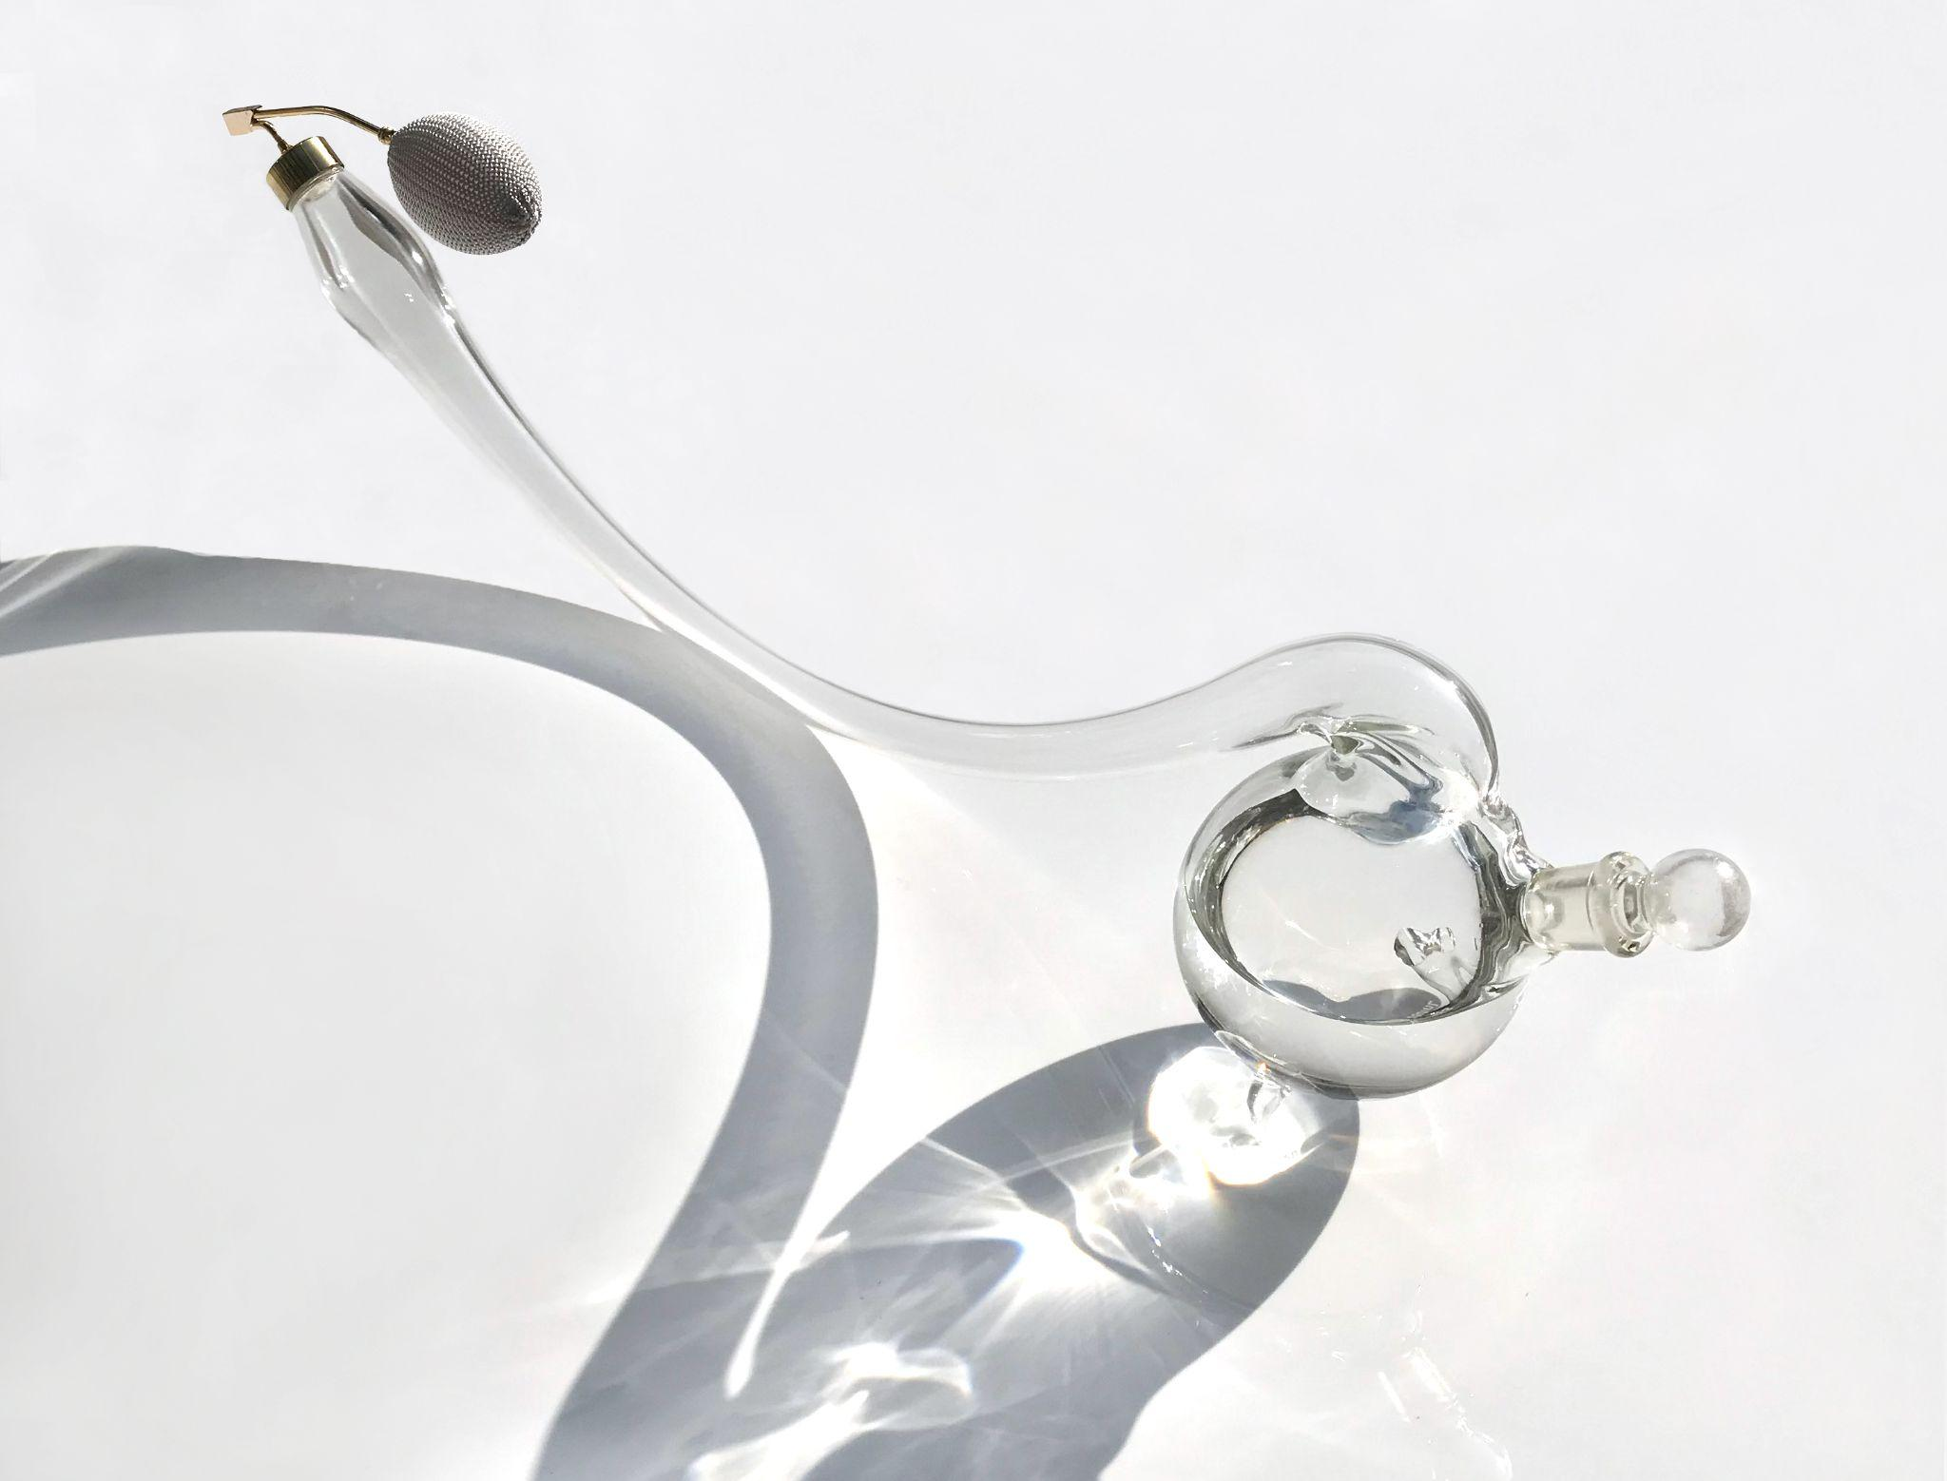
Spray it, Don’t Say it. Communication, Emotion, and Memory: This section explores alternative modes of communication and remembering through olfaction. These designers explore the possibilities of creating meaningful interactions by deliberately communicating and engaging with one another, and also with non-humans, through the sense of smell. Some of the objects and wearables in this section were created to capture a present moment, revive the past, or reconnect to distant times, people, or places. In her project Every Word Was Once an Animal: Sceloporus (2018), artist Carla Bengtson worked with biologists to develop a perfume based on scent pheromones produced by Sceloporus lizards. These lizards use their scent to communicate and attract mates; translated for use by humans in Bengtson's perfume, the pheromones have a citrusy/flowery scent.

Working with and around the sense of smell, taking into account its neurobiological, historical, social, and aesthetic specificities, the designers in this exhibition attempt to change the way we relate to and interact with the world. Their informed efforts are an incentive to use our nose to observe objects from a different point of view, and conversely to use objects to take advantage and make sense out of smell in novel ways.

Participating Designers/Artists
Claudia Adiwijaya, atelier oï, Lena Beigel, Gilles Belley, Carla Bengtson, José Bermúdez, Sofia Caraza, Peter de Cupere, Julie de Mol, Ebram Investments, Virginia San Fratello and Ronald Rael, Philipp Emrich, Antonio Gardoni, JIA Design Team – Spencer Hung, Kaja Solgaard Dahl for Atelier Kaja Dahl, Karen Campa, Katie Dobberstein, Fabien Florek, Corinna Hartinger, Kin Objects, Jody Kocken, Zsofia Kollar, Noé Duchaufour Lawrance, Ani Liu, Monica Förster Design Studio, Nendo, Lizzie Ostrom (Odette Toilette), OVR Technology, Patrick Palcic, Sara Ricciardi, Charline Ronzon-Jaricot, Rui Pereira and Ryosuke Fukusada, Lena Saleh, Ariane Shirvani, Susana Soares, Studio Forest & Whale by Wendy Chua and Gustavo Maggio, studio Outofstock, Tipstudio, Unfold Studio (in collaboration with Barnabé Fillion), Liza Witte, Zanellato/Bortotto Studio

The exhibition is an IMF Foundation production in collaboration with the EP Studio.

The Museum of Craft and Design’s exhibitions and programs are generously supported by the Windgate Charitable Foundation and Grants for the Arts. Additional support is provided by Robyn and John Horn, Hunter Douglas, and Dorothy Saxe.

*Visitors with scent sensitivities can alert the front desk to be informed of which artworks to avoid. As per San Francisco City guidelines, visitors will be required to leave their masks on, even when smelling the activated artworks.

Above Images (top to bottom): Charline Ronzon-Jaricot, L'Ascentium, 2015. Image courtesy of the artist. Monica Förster Design Studio by Monica Förster, Scentainer, 2019. Image courtesy of the artist. Jody Kocken, Perfume Tools, 2011. Image courtesy of the artist. Virginia San Fratello and Ronal Rael, Emerging Objects Coffee Pot, 2018. Image courtesy of the artist. Carla Bengtson, Every Word Was Once an Animal: Sceloporus, 2018. Image courtesy of the artist.
###

For more information and interview requests, contact Sarah Beth Rosales, Marketing and Communication Director, Museum of Craft and Design at sbrosales@sfmcd.org or 415.773.0303.

About Elisabetta Pisu
Elisabetta Pisu is a design curator with training in Sociology and Cultural Management. She has specialized in contemporary design, with a special focus on the production process, social significance, and the evolution of new expressive languages. Objects, environments, and architectures are her main interests, as she investigates the changing role of design in contemporary society. In 2016 she founded EP studio to work on the conception, curatorship, and organization of international design exhibitions. She has collaborated with renowned institutions and has curated exhibitions for prestigious design museums such as Design Museum Gent (Belgium), Cube Design Museum (Netherlands), Design Museum Holon (Israel), Museum of Craft and Design (San Francisco, USA), MODA Museum of Design Atlanta (Atlanta, USA), Tianjin International Design Week (China), L.A. Mayer Museum for Islamic Art (Israel).

About Clara Muller
Clara Muller is a French curator and art historian pursuing scholarly research on the politics of breathing in contemporary art, and the diversity of art practices using scent as a medium. She has contributed to a number of publications on the subject, such as Les Dispositifs olfactifs au musée (Nez éditions, 2018) and Olfactory Art and the Political in an Age of Resistance (Routledge, 2021), and has given several talks in Europe about the crossroads between art and olfaction. She is also a writer for the French olfactory magazine NEZ.

About the Museum of Craft and Design
The Museum of Craft and Design (MCD) is San Francisco's only museum devoted to craft and design. Founded in 2004, MCD showcases designers, makers, and artists through an exciting and distinctive series of craft and design-focused exhibitions and public programs. As a non-collecting institution, the museum actively collaborates with artists, designers, museums, and universities, as well as design venues and practitioners to create inspirational experiences in the world of craft and design for visitors of all ages. Learn more at sfmcd.org

Visitor Information
The Museum of Craft and Design is located at 2569 Third Street (between 22nd and 23rd), in the historic American Industrial Center in San Francisco’s vibrant Dogpatch neighborhood. MCD is a North American Reciprocal Museum (NARM) member, a Blue Star Museum, and participates in ROAM. MCD offers free admission to our nation’s active-duty military personnel and their families, including National Guard and Reserve, year-round.

